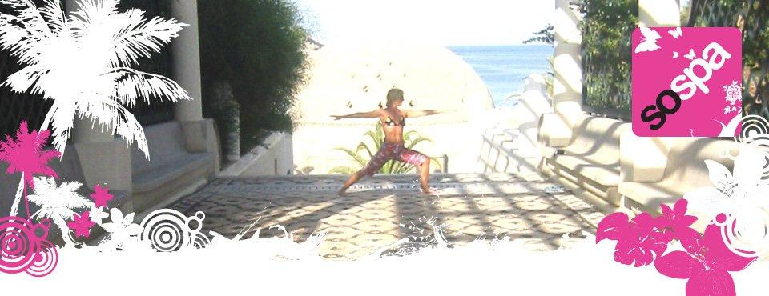
Bespoke Fitness Holiday Package Itinerary for week 4th to 11th June 2011
What we got up to!!
The SoSpa Adventure Begins.

SATURDAY DAY 1
Transfer to Resort arrival approx 21.55hrs.
Check In at Lindos Gardens.
22.30 Leg stretch walk and Light Supper
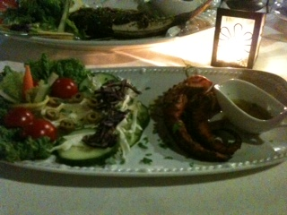

SUNDAY DAY 2
07.30-Power Walk and swim drills. Lindos Main Beach
09.30 Breakfast

11.00 Beach and rest and relaxation

12.30 Aqua Aerobics.

14.30-Lunch on beach

16.00 Beach Tennis/Swim

Snack
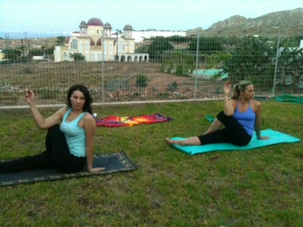
18.30 Yoga relax
20.30 Dinner in the local village
MONDAY DAY 3

07.30 -09.00 Bootcamp Fitness and Swim
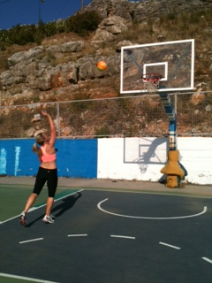
10.15 Breakfast.

12.00 Beach Tennis

Rest and Relaxation.

14.00 Lunch.

15.30 Aqua Box.

Snack

Rest and relaxation
20.00 Dinner
TUESDAY DAY 3
07.30 Sea Running Drills and Swim

09.30 Breakfast

11.45 Core Aqua

14.00 Lunch

15.30 Beach Tennis

Snack

18.30 Yogailates

20.30 Dinner

WEDNESDAY DAY 4

07.30 Tennis

10.00 Breakfast

11.00 Power walk and swim

14.00. Lunch
15.30.Cardio Aqua

17.00 Rest and Relaxation

Snack

18.30 Massage

20.30 Dinner
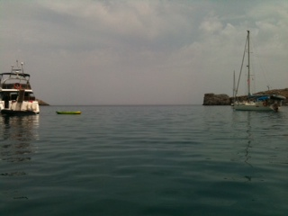
THURSDAY DAY 5
07.30 8.45 Tabata Circuit/Football stadium

09.30 Breakfast
11.30 13.00 Pedalo Main Beach Lindos 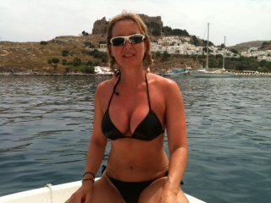

14.00 Lunch

Rest and relaxation

Snack

18.30 Pilates

20.00 Dinner

FRIDAY DAY 6
07.30 Jog,Climb,Swim in Vliha

10.00 Breakfast

11.00-Yoga relax

14.30 Lunch

16.00 Drills and Aqua Fitness Lindos Main Beach

Snack
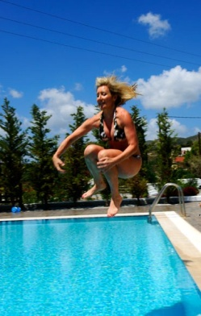
20.00 Dinner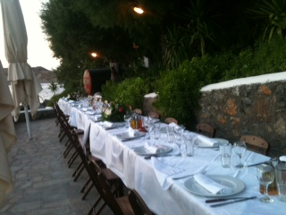

SATURDAY DAY 7
07.30 09.00 Fell Walking to Cleovoulos Tomb and Swim

10.00 Breakfast

11.00 Checkout

12.00 Aqua Fun Faliraki Beach

Rest and Relaxation

14.30 Lunch in Old Town
Home the holiday ends but the memories stay forever...

