“
Kiwi and Strawberry Smoothie
It is a very healthy beverage. Enjoy!
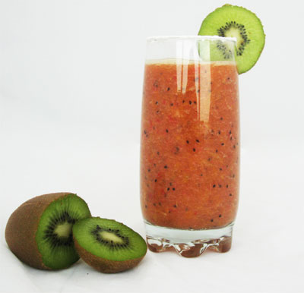 | INGREDIENTS  3 peeled kiwi  1 cup frozen banana slices  3/4 cup pineapple juice  1/2 cup frozen strawberries
DIRECTIONS
- Put all ingredients into blender.
- Blend until smoothie consistency is reached!
Seved in a chiled glass

