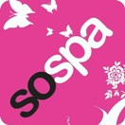
Lichfield Half Marathon Pasta Party
Après Lichfield
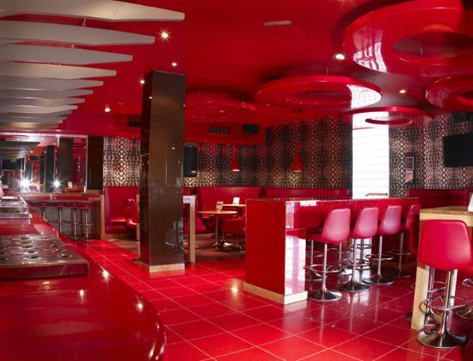A
Saturday 4th May 2013
£5.00 per ticket 5pm till 7pm bar open late
Contact gail@sospa.co.uk 07818 492 578 kevin@sospa.co.uk 07531 395 583
Book on line @www.gailabbey.com

